ANALYTICAL CHEMISTRY

**Regions of electro spectroscopy**:-

In general, electromagnetic radiations are a means used to transmit energy through vacuum. Radiations need no means to transmit; they have a limited energy and a speed equal to the speed of light. That is, they move in the form of orthogonal waves upon each other Sin Ө, Cos Ө electromagnetic. They are varied in terms of frequency and energy according to regions of magnetic spectrum as well as the effects they make for the material. Mass is an accumulation of energy. Mass or material is discontinuous. That is, it is composed of smaller particles (basic units) to a specific limit while energy is continuous and this fact is approved by quantum laws. This means that mass has the corpuscular property only and momentum while energy has both properties, waving and corpuscular together. Thus, anything that has a momentum is a substance having mass.

There is doubly concerning the mass, say, the particle, like photons, has both the corpuscular and positive properties. A wave, unlike the mass, undergoes diffraction and refraction.

Mass can be transferred into energy and vice versa depending on circumstances. An electromagnetic radiation can be divided into different regions connected with one or more of energy states of a molecule. It is observed that such regions may interfere with each other that no adequate limits can be set up for such regions:

**1 –** Universal energy is of a very high energy and is a mixture of several spectrums such as sunshine.

**2 -** ɣ - rays can be obtained by making changes in the energy of the nucleus which lead to internal nuclear changes with frequency 3 x 1o 19 Hz

**3 –** X-rays can be obtained by making spectral changes including the interior electrons of the molecule and the transitions involve making energies exceeding 10 7 J mol -1 . X- Rays frequency is 3 x 10 18 Hz.

**4 –** The region of UV-Viss which are made due to electronic transitions of valance electrons from a specific molecular orbital to another. This type of spectroscopy is called "electro spectroscopy". Its frequency is 3.75 x 10 14 Hz – 3.75 x 10 16 Hz. (1 A o = 10 -8 cm) 40 A o – 8000 A o. The energy difference is referred to as (A o) or (nm).

**5 –** Infra – red (I.R) rays region:

It can be obtained by the transitions between the vibrational energy levels of the molecule. It is called "vibrational spectroscopy". The difference of energy is measured by (wave numbers) and the unit is (cm **-1**). Infra – red I.R rays region can be divided into three regions:

**A –** Near IR: which is near the visible region

**B –** Mid IR: its wave number is between 400 cm -1 – 4000 cm -1 . It is important to diagnose the function groups of compounds.

**C –** Far IR : it is far from the visible region .

IR causes vibrational and bending movements for bonds. Its frequency is between 1 x 10 12 Hz – 3, 75 x 10 14 Hz.

**6 –** Microwave rays region, tiny wave's spectrums: they are made through the transitions between the levels of the rotational energy of a molecule. The spectroscopy of the electronic spin resonance can be studied in the microwave rays region whose frequency is about 1x 10 10 Hz – 3 x 10 12 Hz.

We need for the pure rotational spectra in our study. For the wave or spectrum to be microwave rotational, a change in the dipole moment should take place while the substance is in the gas state and used in chemistry for melting substances and in communications in civil actions. Its energy is about hundreds of Joules 100 J / moles

---------------------------

∆ E = hɣ(HZ or sec-1) , E=hc/λ , V = 1/λ , Where V: wave number(cm-1) and λ : wavelength (cm) , h: Blanks constant (erg.sec-1) ,C: Velocity of light(cm.sec-1) , C=λ× ɣ

----------------------------

In the microwave spectrum which is intra with the waves is the electro factor while in NMR, intra with the magnetic factor only. In order to the interference to take place, the molecule should be in the gas state and has electromagnetic field. Its applications are the study of rotational spectrums and chemical interactions.

**7 –** Radio wave region

They are electromagnetic rays with a low frequency, low energy and high wavelength obtained by the change in the direction of the single electrons spinning in terms of ESR and change in the spinning of the magnetic nucleus in terms of NMR.

L --------------------------- {---------}.........} Rotational

Electronic transition Vibrational

K---------------------------

**Absorption and emission of electromagnetic spectrum:-**

An atom or a molecule is transmitted or moved to a state of high energy upon the absorption of energy by such atom or molecule. Each excited state has a specific number of energy levels. The possible multi levels are regarded as one of properties of a specific atom or molecule. The figure. Shows a plain diagram of an atom or molecule's energy levels. The two horizontal lines refer to the energy levels of a particle where the electronic ground state with low energy Eo and E* is the electronic excited state with high energy. When energy is added in the form of heat or light, the electron is capable to jump from Eo to E* in such a way that the atom or molecule will be in an excited state after the absorption of such energy and the particle may lose – during the excited state – the increase of energy via a number of processes which are:

First, the electronic particle may hit the solvent's molecules or any other molecules transferring its energy to the domain of such molecules. Second, the particle may become inert by releasing the photon (emission ) which is equal to the energy difference between the two levels and in both cases the molecule or atom ends with the electronic ground state .

**Instrumentation:**

In general, the basic design of instrumentation used in the areas of the electromagnetic spectrum is the same but the parts and the mono-components can be varied according to the visual area. For example, the infrared detector which responds to the thermal change and is more capable of the photocell .The latter detector is more useful in the UV and visible areas. Visual parts should be transparent towards the area under study. Thus, various materials for optics can be used in different areas. A spectrophotometer is composed of a source of radiation, monochromator , cell of sample and a detector .

**Classification of Instrumental Analysis:-**

Classical methods are based on the qualitative and quantitative also spectroscopic methods or optical spectroscopies are based on the phenomena of absorption, emission or scattering of radiation.

|  |  |
| --- | --- |
| **Analytical method Based on measurement of signal** | **Types of analytical methods** |
| A-Volumetric analysis  B- Gravimetric | Classical methods  A-Volume  B- Mass |
| A- Spectrophotometry  B- Emission spectroscopy  C- Turbidimetry | Instrumental analysis spectroscopy  A-Absorption of radiation  B- Emission of radiation  C- Scattering of radiation |
| Refractometry | Refraction of radiation انكسار الاشعاع |
| Potentiometric | Electrical potential |
| A- Polarography  B- Aerometry  C- Coulrometry | Electrical current |

The energy of electromagnetic radiation could be represented by electromagnetic spectrum regions.

In absorption instrumentation, the source of radiation is separated from the cell of sample as shown in Figure for the comparison purpose while they constituent one single unit in evolution instrumentation.

**Absorption of radiation in UV-Vis Region:-**

Absorption spectroscopy depends on interaction between the photons and absorbing particles (unknown samples).

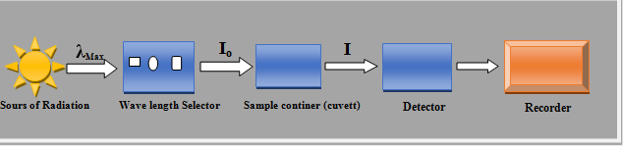

Schematic diagram of single – beam spectrophotometer

There are two types of UV-Vis Spectrophotometers Instruments:

**1 – single – beam spectrophotometer**

Its main parts can be shown in Figure. A prism or grating can be used for the dispersion and analysis of polychromatic radiation into a monochromatic radiation.

and upon the use a filter instead of such monochromators , the device then is called one cell filter photometer . It is applied within a specific wavelength and used for one – compound quantitative assessment when there are many samples due to be analyzed. This device is more preferable in the field of spectrum emission. The light source and detector should have a high degree of stability but one of its disadvantages is that it measures the whole lost quantity of light when crosses through the sample instead of measuring the absorbed light.

**2 - Double – beam spectrophotometer:**

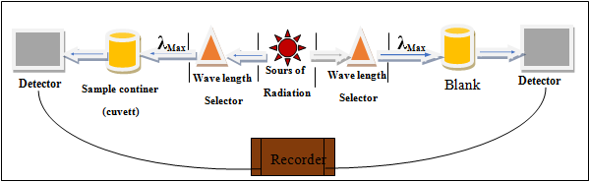

This Figure shows the parts of the double – beam spectrophotometer

And when a filter is used instead of a prism, then it is called a two – cell filter photometer. As shown in the Figure, the device is composed of two monochromators , two detectors and two cells . The sample due to be assessed is put in one of those cells and the blank (the solution which contains all materials except the sample due to be assessed). One of the advantages of double – beam spectrophotometer is that it can measure the light beam percentage of the sample against the light beam of the blank. Thus , any change in the intensity of the beam which comes from the light source do not lead to analytical defaults due to the presence of two cells and two detectors that the effects caused by voltage fluctuation and volatility can be avoided . Moreover, the effects of voltage fluctuation can be removed by using an active battery as a voltage source. A double beam spectrophotometer is used in the absorption spectrums studies.

**Components of spectrophotometer:-**

**First – Radiation Sources**

* Tungsten lamp
* Hydrogen discharge lamp
* Mercury discharge lamp
* Xenon lamp

**Second – Monochromators**

1 – Light Filters: There are three types of light filters:

A – Glass filters

B – Written filters

C – Interference filters

2 – Prisms

3 – Grating

**Third – Detectors**

**Types of Detectors: There are three types of detectors:**

1 – Photocell

2 – Barrier layer cell

3 – Photomultiplier

**Forth – Sample cells**

The designed sample cells from inert materials as quartz or silica

**Quantitative analysis by Spectrophotometer (Laws of Photometer):**

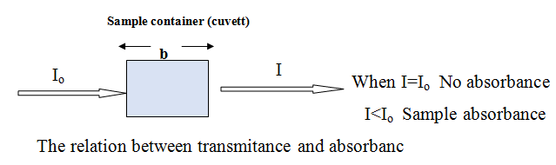

1-The Relation between Transmittance and Absorbance:-

.......1 T= $\frac{I}{Io}$

T%= o) ×100 or T% = T ×100………2

2-Absorbance (A):-

**Absorptivity**: - Is property of absorbing substances to gather with a solvent at certain wave length ( λ ) its in dependent on the concentration (C) . And path length or width (b) of the solution.

**Laws of photometry:**

**Spectrum quantum analyses depend on basic laws:**

**1 – Lambert law** this law is also called (**Bouguers law**). It stipulates that in case monochromatic light passes through a solution of a constant concentration, the solution absorption is proportioned directly with the cell width containing the sample.

Knowing that:

T = Transmittance

A = Absorbance

a = absorptivity constant or darkness constant (L.gm-1.cm-1)

C= concentration of absorbing substance = mol L-1

b = path length (thickness of the cuvette) or Sample container (cuvette) = cm

Io= initial radiation (100) (before passing the solution)

I= Transmitted radiation (after passing the solution)

**2- Beers law:**

When monochromatic radiation passes through a solution contained in a cell with a constant width, absorbance is directly proportioned with the solution concentration:

**3-Beer- Lambert law:** this law is also called "Beer Law" > It is the result of the merger of both (Beer law) and (Lambert law). It can be explained by the following equation:

A = ɛ . b . c

}

**………3**

A = a . b . c

IF the concentration in mol L-1 or (N ) or (F) , (A) is replace by ɛ) but the concentration in gm L-1 (**a**) in beers Law then :

Knowing that:

**ɛ** = molar absorptivity coefficient and it is measured by( L . Mol-l . Cm-1 or L\ Mol . Cm)

**a** = absorptivity constant or darkness constant (L.gm-1 .cm-1)

**=** ɛ.b or (a.b)**……..**4 **A=** Log $\frac{Io}{I}$

……..5 A= -Log $\frac{I}{Io}$

A= -Log T ……….6

……..7 A = - Log $\frac{T\%}{100}$

A = -Log (T%-100)….8

A = 2-Log T% ………9

Where : A= ɛ b c

……10 **ɛ= $\frac{A}{bc}$**  So:

**Sensitivity of Spectrophotometric Method**

Sensitivity can be represented by the two terms mentioned below:

**1 – Sandal's index**

It is also called (sensitivity index). It is defined as the number of micrograms of the solution due to be assessed which is transformed into a colored product and occurs in a solution with a cross – section of 1 cm and gives absorption = 0,001 absorbance unit

Sandal's index = $\frac{M}{ɛ}$

That **ɛ** = molar absorptivity coefficient

M = Molecular or atomic mass which is equal to the molar absorptivity coefficient

**2 - Molar absorptivity coefficient**

It can be measured by applying Beers law. To obtain more adequate value, the molar absorptivity coefficient should be measured by undertaking the average of the molar absorptivity coefficients for each point from the linear relationship (the standard) by applying Beers law.

**Braud** explains sensitivity and states that log ɛ ≥ 4 is because high probability transition (more sensitivity) while log ɛ ≤ 3 is because low probability transition.

**Absorption curve (absorption spectrum):-**

The degree of absorption of substance is usually represented by a curve called (absorption curve).

It's constricted with drawing absorbing values against wave length measurements:

Example:-

150 nm A1 1.1

170 nm A2 1.2

190 A3 1.09

210 A4 1.20

220 A5 1.60

240 A6 1.20

250 A7 1.10

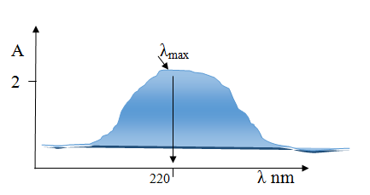

**λMax**:- A certain wave length in which a certain a absorbing substance have maximum absorbance

**There are four methods to determine of quantitate samples as:**

**1- Standard comparison method:**

When (A1) is absorption of Known solution and (A2) is absorption of standard solution, also (C1) concentration of Known Solution and (C2) Concentration of standard Solution.

**= $\frac{C1}{C2}$ $\frac{A1}{A2}$**

**2- Standard addition Method:**

In this method preparing two solutions; the first one containing Known solution, the second solution containing parts of volume from first one with volume from Standard solution so, and the absorption for first and second solution by equation:

**Cunk =**

**3- Beers law method:**

In this method; can be determining Concentration of absorption solution when available molar absorption constant (ɛ):

**4- Calibration method:**

In this method; drawing a concentration values (X-axis) against absorption values (Y- axis). So the straight line between X and Y axis's refers to correlation coefficient for (A, C) where a drop line (xy) refers to unknown concentration.

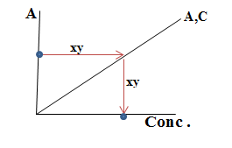

Q1:

The energy difference between ground state Eo and exciting state E* is 2.107 eV . Calculate the wavelength of Radiation to transition of electron between the states ?

(1 eV=1.60×10-19 Joule) ,( h: blank constant =6.63×10-34 Joule .Sec ) ,(Velocity of light = 3.0×1010 cm .Sec-1)

Solution:

λ= hc / E

λ= 6.63×10-34 Joule .Sec × 3.0×1010 cm .Sec-1

2.107eV ×1.60×10-19 Joule .eV-1

λ= 590×10-7 cm ×107 nm .cm-1

λ = 590 nm

1 cm = 107 nm

1 m = 109 nm

1 cm = 108 Ao

1nm = 10 Ao

1 m = 1010 Ao

1 m = 106 µm

1 cm 104 µm

1 µm = 103 nm

Q2:

Two solutions where taking 5 ml for each one. Dilute the first solution (unknown) into 10 ml by added deionized water to giving absorptivity 0.350 . Where added 5 ml from first solution into second solution (standard solution) which possess concentration 5.0x10-4 M so; the total absorption for both solutions 0.465. What is concentration of first solution (unknown)?

Solution:

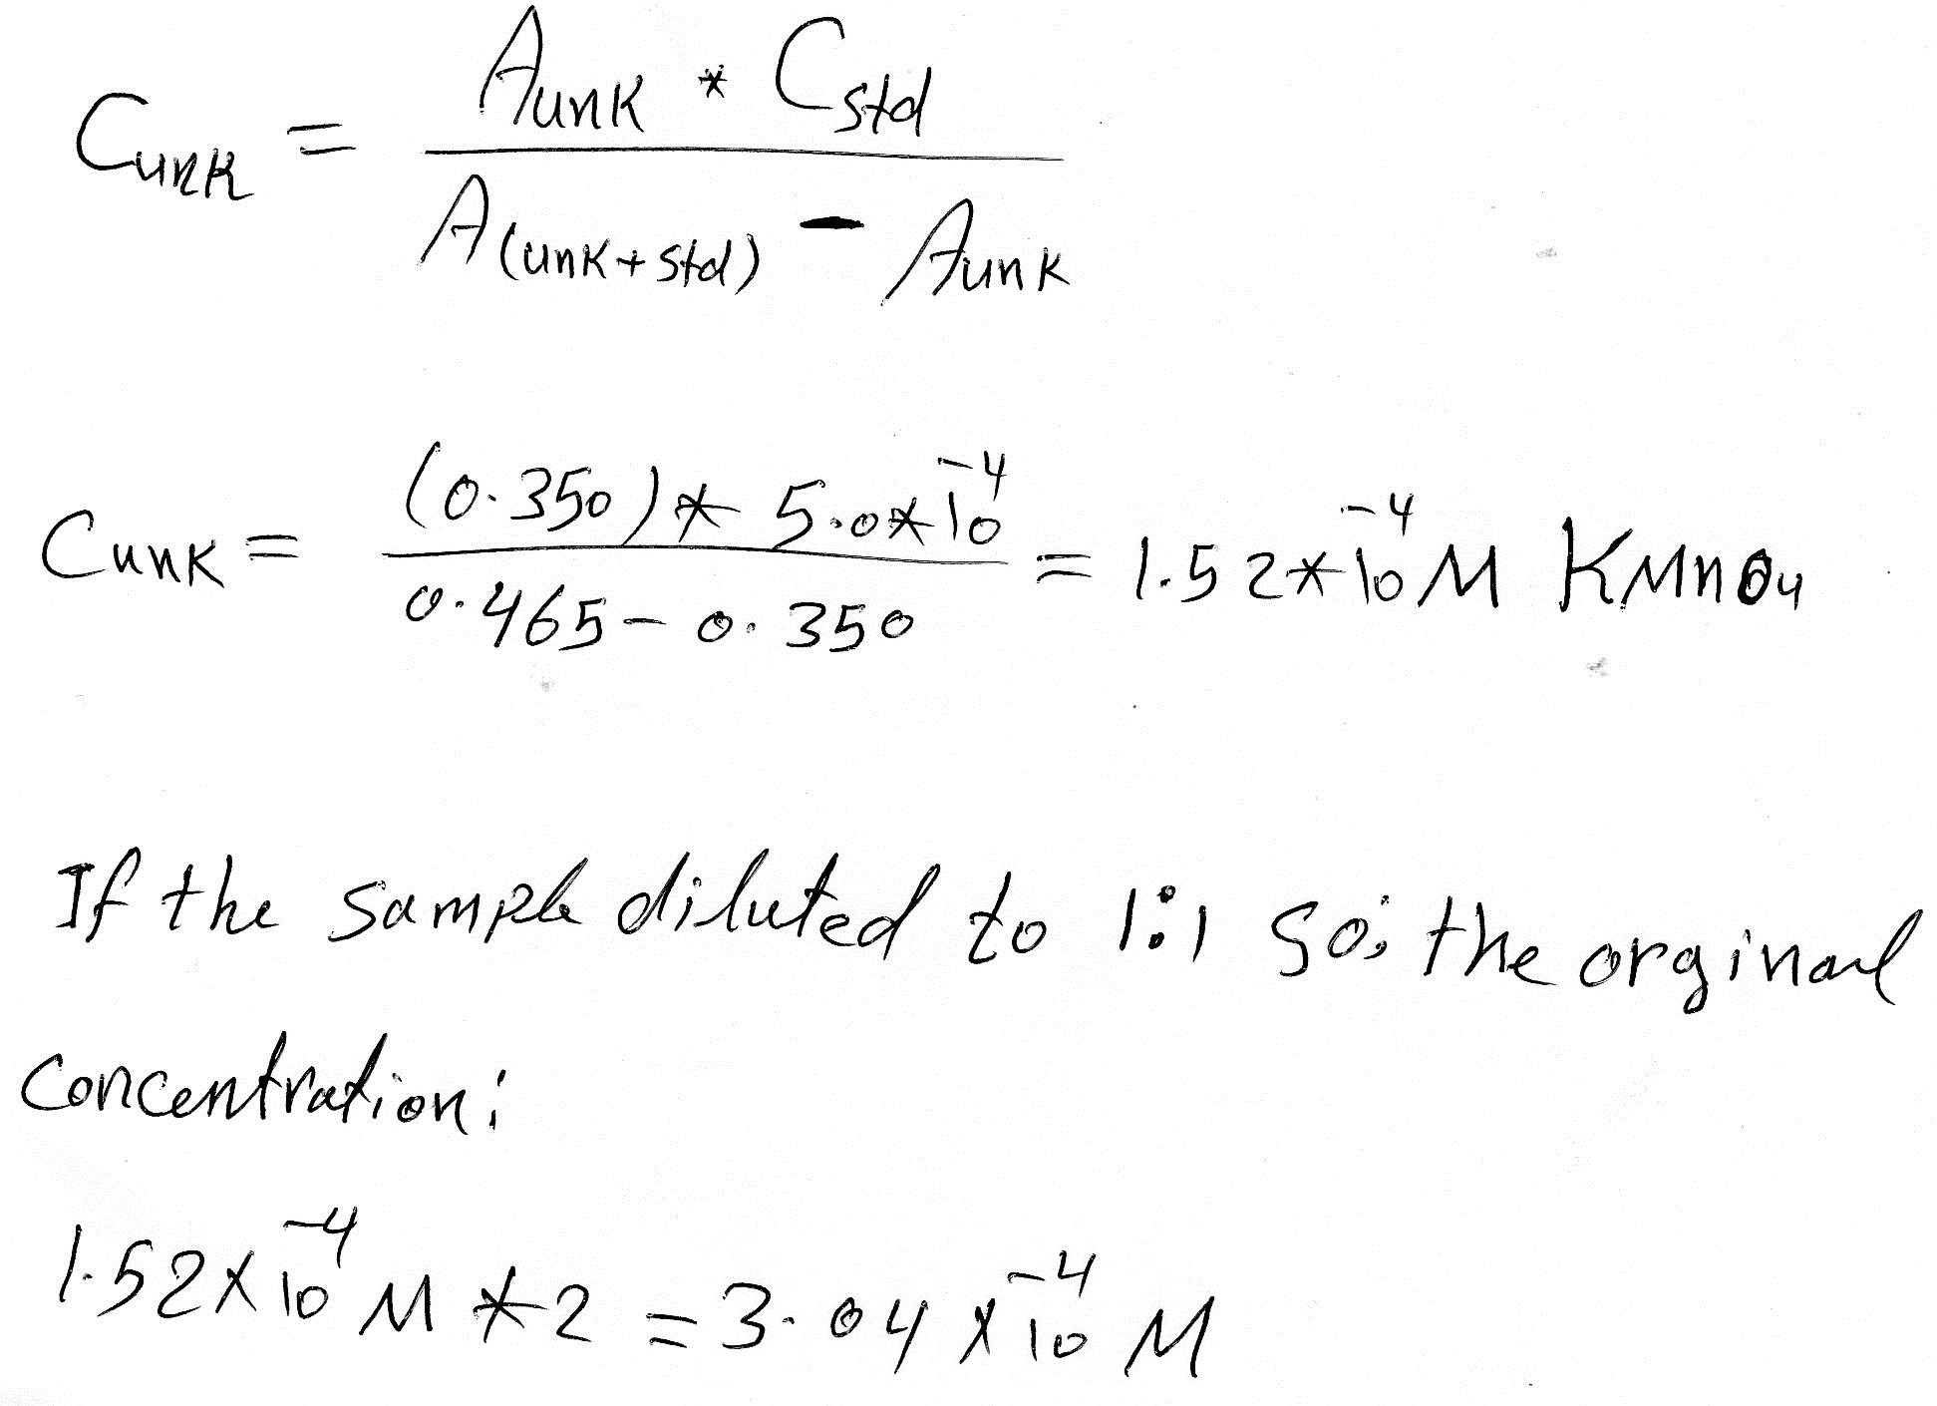

Q3:

A ferric sample without corrosion weighting 1.0 gm and containing (Mn). These samples dissolve in Nitric acid and Oxidation of (Mn) in sample into KMnO4 by using KIO3 and take place 100 ml from this solution and dissolve into 100 ml So; the solution giving absorption 0.7 in the pass cell light 1.0 cm . In the other hand; using standard solution from KMnO4 having concentration 1.5x10-4 M, where the absorption for this standard solution 0.350. What is the percentage of Manganese (Mn) in the sample?

Solution:

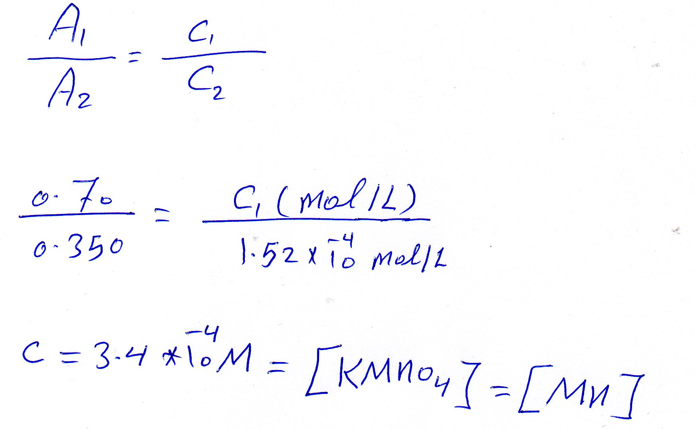

**% Mn =**

3.04×10-4 (mol/L) ×54.94(gm/mol) ×(100/1000) %Mn= 0.17%

1.0 gm

Q4:

Potassium chromate which appearance in basic media maximum absorption at λmax 372 nm and following for basic solution from K2CrO4 that possess concentration 3.0x10-5 M and transmitting 71.6% at λmax 372 nm in the path cell 1.0cm .

A- What is the absorption of this solution?

B- What is the molar absorption?

C- What is the transmittance percentage when bath cell 3.0 cm?

Solution:

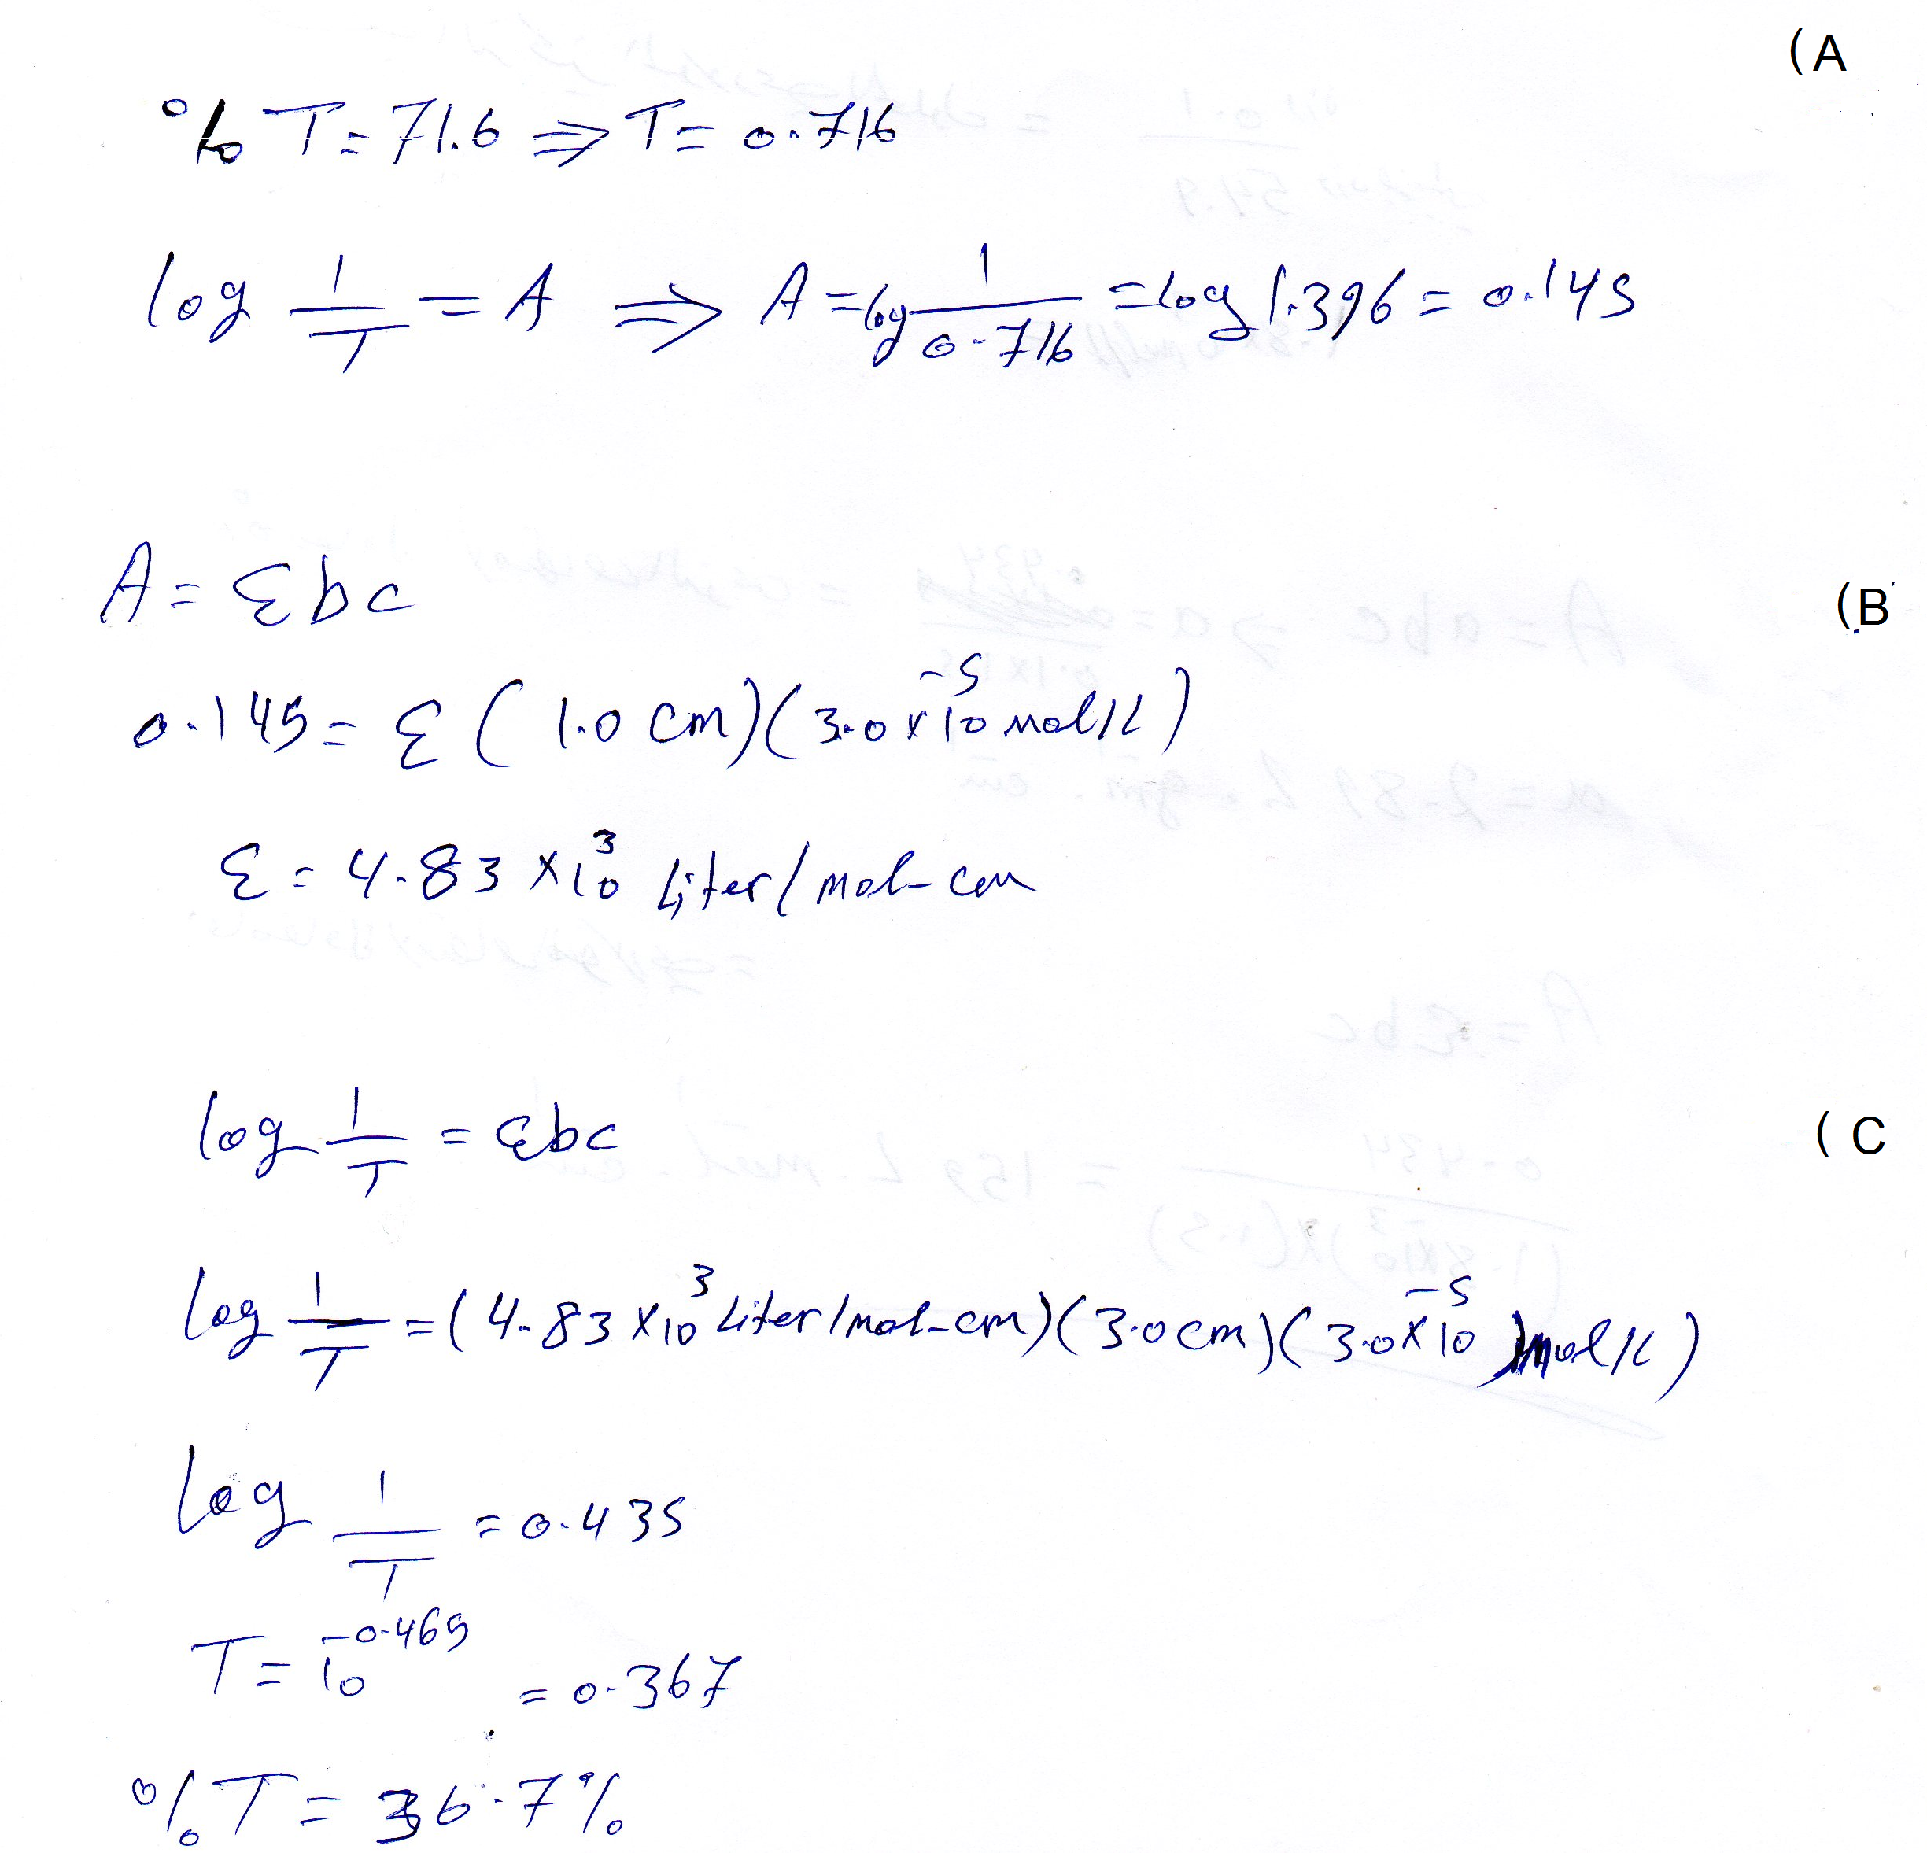

Q5:

100 ml solution containing 0.01 gm for Potassium permanganate where the absorption 0.434 at pass cell light 1.5 cm and λmax 550 nm . What is the absorption constant and molar absorption coefficient for Manganese (Mn) only?

Solution:

